Caring for and sharpening hand tools

**Richard Lloyd, Palmerston North Repair Café 2025**

There are many different philosophies on tool care and sharpening – there isn’t one ‘right way’. Below are a few suggestions. There are lots of videos on You Tube, many of which are helpful.

* In most cases, a good quality, sharp and well-maintained tool will work a lot better and is generally safer to use as you don’t need to force things or work as hard.
* Appropriately sharp – a spade doesn’t need to be as sharp as a wood chisel!
* Where I have suggested a brand or given a link, it’s just an example I happen to have liked.

**Common (mostly obvious) themes**

Most cutting, chopping or digging hand tools are made from steel. They often have wooden handles. Steel will rust and wood will split or degrade if not looked after. A few pointers:

* Buy quality, buy once – often old second-hand hand tools are better quality than new.
* Keep tools clean and dry. A light oil layer on steel will prevent rust.
* Oil wooden handles with Danish oil e.g. Rustins (Mitre 10) or some form of outdoor furniture oil. A light sand (~200 grit) and a quick wipe now and then will preserve the wood for generations.
* A sharp single cut mill file (e.g. Bacho brand) can be used for spades, axes, loppers and some secateurs etc. Look after files by not clanking them together and store them dry.
* Rockwell hardness (Rc) is a measure of material hardness. The hardness of the sharpening tool e.g. file (Rc>60) just has to be higher than the thing to be sharpened. Woodwork chisels, planes irons etc. are too hard to file and need another approach as discussed later.
* Don’t despair - rusty tools can often be saved. Wire brush/sand off the rust, soak in 5% citric acid or apply a ‘rust converter’ (tannic acid) which forms a blue-black protective layer.

We’ll look at a few tools in the order of least sharp and softest steel and work to the sharpest/ hardest steel except I’ve added a bit at the end on hand saws, the sharpening of which is a bit less common these days, for anyone who is interested.

**Spades, hoes etc**

We don’t need to have a razor sharp spade but a sharpish spade will make digging a lot easier.

* 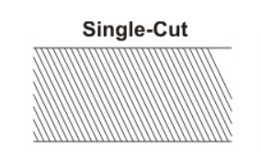Old Forged spades (and forks, hand trowels etc.) are far stronger/better IMHO than modern pressed steel, or even stainless steel spades. But they require a bit of looking after. Put them away dry and clean, oil the wood occasionally with Danish oil, use a bit of spray on the blade such as CRC or Inox (lanolin).
* Use a single cut mill file (pictured) to bevel the edge. Traditionally the under-side of the blade was bevelled on spades and the top on shovels. These days the top seems to be bevelled on most.
* It’s easiest to clamp the spade to a bench and file a bevel. You can’t really muck it up. The angle should be ~45°… ish.

**Axes**

* New axes are generally fairly blunt so benefit from some sharpening before use.
* The safest way to sharpen an axe is to clamp it horizontally to a bench (less likely to slip and cut fingers). You tube has some good videos, just Google ‘how to sharpen an axe with a file’.
* Axe heads are quite hard (Rc ~55-58), and some are just too hard for a file. But for most, use a sharp mill file to get a primary bevel, maybe 8 to 10 mm back from the edge in most cases. Then cut a secondary bevel using a few strokes with the mill file – the steeper angle of the secondary bevel will be more robust (see the picture below). Draw filing gives a sharp edge.
* Can use fancy oil stones etc. to hone the secondary bevel but unless you are into competitions, a filed axe will generally be plenty sharp enough.
* Keep the axe heads clean and oiled and wipe the handle with Danish oil if it is wooden.
* Take axes seriously. They are dangerous (speaking from experience)!

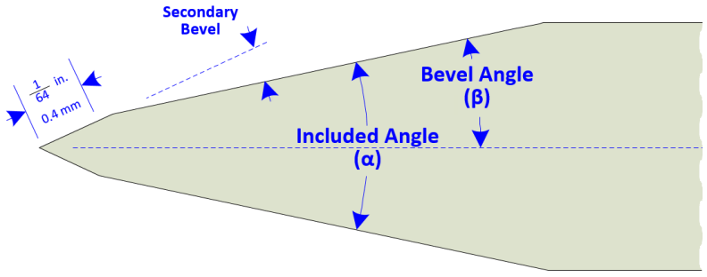

**Pruning and cutting tools like loppers and secateurs**

* These are usually made from hardened and tempered steel (Rc~59). They can often be sharpened with a sharp mill file but it’s usually easier to use a small diamond stone e.g. Eze lap to get into the corners.
* Before sharpening, clean the sap off with wire wool (e.g. goldilocks) and some spray lubricant like CRC.
* Only sharpen the blade bevel. Try to follow the existing bevel angle. 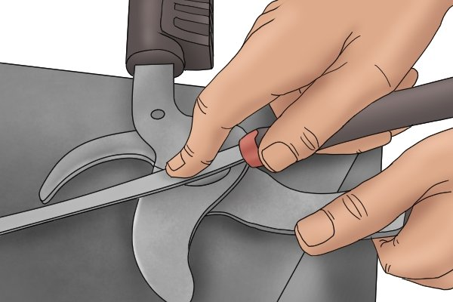 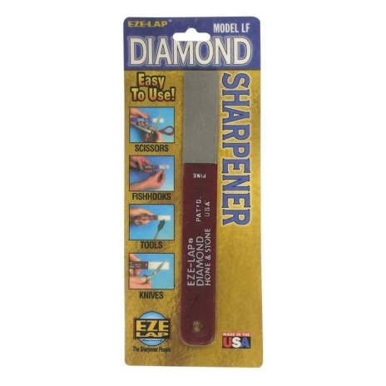
* Remove the burr on the back of the blade with a diamond stone but Do NOT round over the back side of the bevel – keep the stone flat on the back of the blade.
* If the secateurs/loppers have become very blunt, it is possible to flatten the back surface – take them apart, and use a diamond stone or fine emery paper on a flat surface. Likewise the anvil (lower blade) can also be flattened if needs be. Or bring them to the Repair Café.
* Keep them dry, clean and oiled.

**Knives**

There are many sharpening contraptions for knives – too many to cover here. Use a diamond stone or a knife steel or 3D print a fancy one like this <https://www.thingiverse.com/thing:4135236> – they work well. Free-hand, it’s a matter of getting a consistent angle and takes a bit of practice.

**Woodwork hand tools – e.g. chisels and plane irons (blades)**

* Many people these days seem to have discarded old hand tools in favour of power tools. But hand tools like planes and chisels have many uses. Planes can quickly give an accurate smooth surface and chisels can cut tight joints and shape wood. They can be a real pleasure to use if they are sharp. If they are blunt they are frustrating which is why most folk give up on them.
* With the exception of high-end tools, you are much, much better off with second-hand woodworking hand tools. In fact, the older the better usually (IMHO) pre WW2.
* Plane irons and chisels have a primary bevel (like β on the axe picture) and a secondary bevel.
* The steel is hardened and tempered to take and hold a very fine edge (Rc 60-62+).
* A primary bevel at ~25° can be done with a grinding wheel – most folk don’t have these so get a woodworking friend to grind them or bring them to the Repair Café. Don’t overheat them when grinding as it’ll ruin the temper.
* A primary bevel can also be done using the honing techniques below, but it is slow.
* A secondary bevel (as previously mentioned for axes etc.) is a small steeper angle on the end of the cutting edge that is very sharp and produced, in this case, by honing on a fine abrasive surface. Two common honing methods are using a stone such as a diamond and/or water stone or use emery-type paper on a very flat surface e.g. a glass plate. The second approach is cheaper to set up. There are lots of videos on You Tube. Beware of people who say this is the only way!
* The back of the blade also needs to be flattened on a flat fine abrasive surface such as a diamond plate etc. Most people forget this bit.
* Some people say you are only a woodworker when you can hone freehand. But I always use a honing guide which is cheap and available in town e.g. the Eclipse-style guide (below). It precisely sets the angle. 30° is a good starting angle for both chisels and planes.
* Like all the others, chisels, planes and so-on are made of ferrous metal and will rust. I like to coat my tools in Inox - a lanolin based spray (which can be bought from e.g. Mitre 10 or Jaycar).
* Planes can take a while to set up initially but it’s worth it. If you want practical help, bring your old Stanley or Record plane to the Repair Café and we will get it taking fine shavings. Probably.

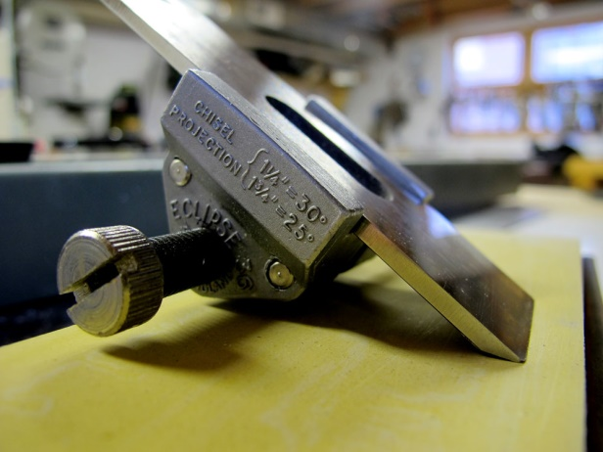 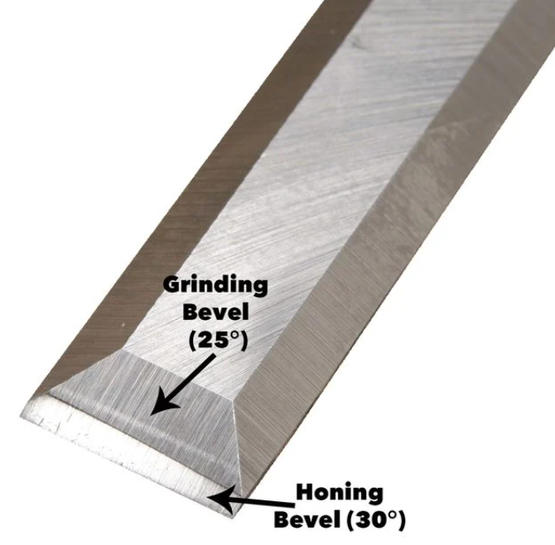

**Scissors**

If your scissors are valuable or are used for fine work, dressmaking etc, it’s best to get them sharpened professionally as scissors have a complicated profile which is easy to damage. If they are general purpose e.g. kitchen scissors, it is worth having a go yourself. Hold the scissors in a vice and use small diamond stone or draw file with a mill file as for secateurs. Do not file the back of the blade apart for a gentle de-burring with a diamond stone. Some very well made new scissors are still available that will last a lifetime (or more) such as William Whiteley or Earnest Wright – Google them if you like. You get what you pay for!! E.g. <https://www.whiteley.co.uk/> .

**Saws**

Apart from a very few traditional saw makers like Thomas Flinn in Sheffield <https://www.flinn-garlick-saws.co.uk/> , most modern hand saws are not able to be sharpened as they have very hard teeth. They can last quite a long time but when they are blunt, throw them away (or chop them up for cabinet scrapers…ask us how!). Throwing away is not what we are about at the Repair Cafe. Old hand saws are sold cheaply and there are many fine examples on Trade Me. Or you may have one or more languishing in the shed gathering dust. As long as they are not pitted with rust, they can be cleaned up with some wire wool, and paste wax such as Briwax will prevent further rust. Wooden handles can be sanded and restored with our trusty Danish oil. They can be sharpened over and over with a small triangular file. There are 2 sharpening patterns: Rip or crosscut. Rip is quite easy as it is just a matter of filing straight across the saw tooth with the correct rake as shown. Cross-cut is a bit more complicated but quite achievable with a bit of practice. They then have to be set with a saw set to the correct angle depending on the number of teeth per inch to prevent the saw binding in the wood. It is much easier to watch a video than explain and there are some great tutorials by Paul Sellers and others on-line. E.g <https://www.youtube.com/watch?v=UA5DixEaaUo&ab_channel=PaulSellers> or we may be able to demonstrate it at the repair café with some notice!

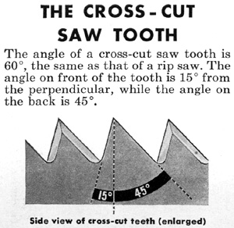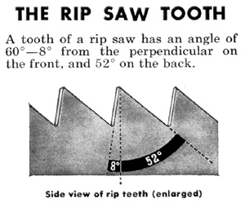

Hand Tools…Buy once, buy quality, look after it and it’ll be come a lifelong friend.