ENM ENVIRONMENTAL INITIATIVES FUND

(EIF)

Guidelines – Small Grants 2023-24 ($1,000 or less, exclusive of GST)

PLEASE READ CAREFULLY BEFORE COMPLETING THE APPLICATION FORM

For questions or assistance please contact or drop in to see:

Kerry Jaques
Environment Network Manawatu
145 Cuba Street, Palmerston North
Phone: 06 355 0126
Email: admin@enm.org.nz

BACKGROUND INFORMATION FOR THE ENM ENVIRONMENTAL INITIATIVES FUND (EIF) – Small Grants

The Purpose of the Fund

The main purpose of the grant is to support community initiatives that align with priorities of both PNCC and ENM to improve environmental outcomes for the city. Grants will be available to projects taking place within Palmerston North's City boundaries.

ENM will set the funding priorities each year based on PNCC’s Eco-City Strategy priorities, and any identified priorities of the network, in consultation with its members.

Applications may be made for Small Grants (up to $1,000, exclusive of GST).

EIF Priorities and Criteria 2023/24

Funding initiatives for the 2023/2024 funding round must demonstrate alignment with the following priorities and criteria for eligibility:

Priorities: the initiative must demonstrate alignment with the following priorities for this year’s funding round (ending 30 June 2024).

Respect and enhance the mauri of the Manawatù River.

Mauri is defined as:
“Life force or essence”

Examples of initiatives that align with this priority are:
The Manawatù River Source to Sea project.
Removal of plastics and other litter from waterways.
Removal of weeds from waterways.
Water quality monitoring of our waterways.
Riparian planting (planting the areas beside waterways).

Focus on community resilience, sustainable living, food security and education.

Community Resilience is defined as:
“The sustained ability of a community to use available resources (energy, communication, transportation, food, etc.) to respond to, withstand, and recover from adverse situations (e.g., economic collapse to global catastrophic risks)”.

Sustainable Living is defined as:
“A lifestyle that attempts to reduce an individual's or society's use of the Earth's natural resources, and one's personal resources”.

Food Security is defined as:
“The state of having reliable access to a sufficient quantity of affordable, nutritious food”.

Examples of initiatives that align with this priority are:
Initiatives aimed at stopping the use of plastics.
Initiatives seeking to reduce energy use and utilise renewable energy.
Initiatives that find creative ways of reusing everything.
Set up and development of community gardens.
Gardening and cooking programmes in schools.

Regenerate and support native biodiversity.

Biodiversity is defined as:
“The variety of plant and animal life in the world or in a particular habitat, a high level of which is usually considered to be important and desirable”.

Native biodiversity refers to:
“Species that occur naturally in a given geographic area. A native species that occurs in a given geographic area is one that evolved in that geographic area, as opposed to having been transported there by humans”.

Examples of initiatives that align with this priority are:
Predator control projects.
Weed control programmes.
Tree planting programmes.
Native species monitoring programmes.

Provide education or development relating to sustainable buildings and/or green spaces.

Sustainable buildings are defined as:
“Buildings that can maintain or improve: the quality of life and harmonize within the local climate, tradition, culture, the environment in the region, conserve energy, resources and recycling materials, ... the local and global ecosystem throughout the entire building life cycle”.

Green spaces are defined as:
“Land that is partly or completely covered with grass, trees, shrubs, or other vegetation). Green space includes parks, community gardens, cemeteries, schoolyards, playgrounds and public seating areas”.

Examples of initiatives that align with this priority are:
.
The Edwards Pit Park Reserve developments.
The Ahimate Reserve developments.
Education in schools via the establishment of green spaces.
Development of new building designs and/or materials.

Climate change mitigation or adaptation.

Climate change mitigation means:
“Avoiding or reducing emissions of heat-trapping greenhouse gases into the atmosphere to prevent the planet from warming to more extreme temperatures”.

Climate change adaptation measures aim to reduce vulnerability to the effects of climate change.

Examples of initiatives that align with this priority are:
Mitigation:
Harnessing new technologies.
Promoting renewable energies.
Improving efficiency of existing energy systems.
Changing management practices or consumer behaviour.
More efficient means of transport e.g., electric public transport, bicycle, shared transport.

Adaptation:
Providing secure facility locations and infrastructure e.g., water tanks.
Landscape restoration and reforestation.
Flexible and diverse cultivation systems in anticipation of extreme weather events.
Reducing consumerism and waste.
Altered food and recreational choices.

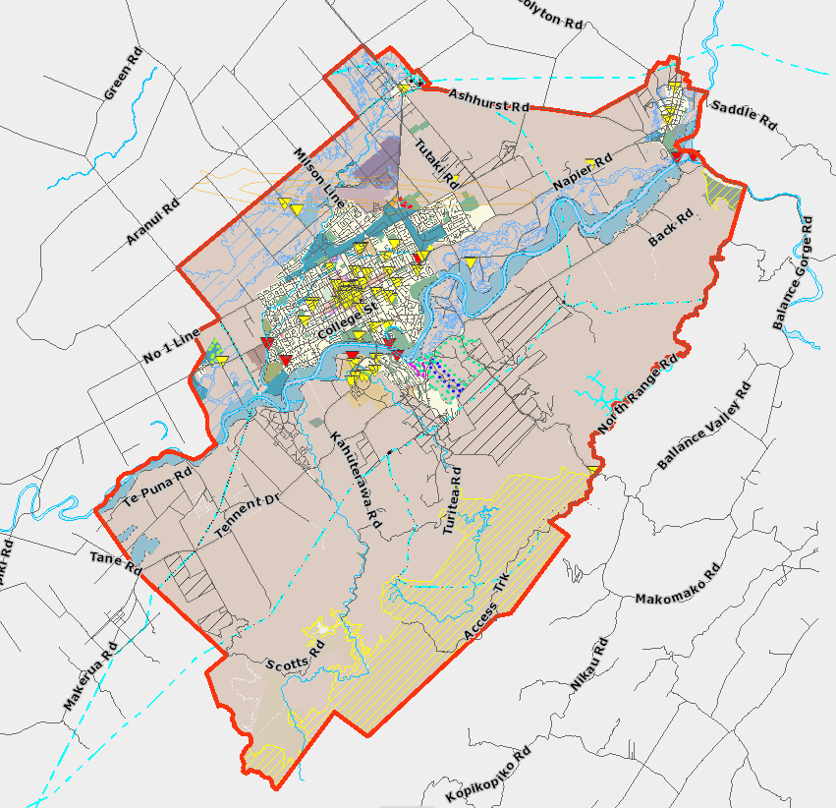
Local Focus: the initiative must take place within Palmerston North City boundaries as stipulated by the PNCC, but applications can be submitted by individuals or organisations from outside city boundaries.

You can find a link to an interactive map showing the city boundaries here

Environmental Benefits: the initiative must demonstrate the specific environmental benefits that will be achieved by implementing the initiative.

Project Plan: applicants should submit a brief Project Plan for their initiative. The Plan should cover the objectives of the initiative, a description of how the objectives will be achieved and the timeline for the initiative. A Small Grant application need not be for a new activity but could cover maintenance or expansion of an existing initiative.

Reporting: how the applicant will measure the initiative’s success – they will need the capability to record and report on the project’s success to ENM.

Applicant Status: applications will be accepted from individuals and organisations. Applications from businesses will be accepted but environmental initiatives must not support profit-making activities.

Requested Grant: must not exceed $1,000 (exclusive of GST).

Paid staff costs: may not be applied for in the budget.

Fund Details

Funding Availability

Applications for Small Grants will be open all year round.

Funding closes when the 2023-24 fund is fully allocated (Large and Small Grants).

The maximum funds an applicant can receive per application (for the same initiative) is $1,000 (exclusive of GST) for Small Grants.

Other points to note when submitting applications for Small Grants are as follows:

- Payment will be by purchase order/s submitted by ENM to specific supplier/s or by reimbursement of invoices for agreed initiative expenses only.
- Retrospective expenses will not be covered by Small Grants. The date that retrospective spending applies to is the date applicants receive notice of funding. Expenses incurred before that date will not be funded.

Fund Allocation Process

Assessment and allocation of funds will be carried out by ENM’s Funding Distribution Subcommittee.

The Funding Distribution Subcommittee (FDS) includes representatives from ENM’s Management Committee, ENM Member Groups and other community organisations.

FDS recommendations to ENM’s Management Committee (MC) regarding Small Grant funding allocations will be made as soon as possible after the application has been submitted (in most cases applicants should expect to have a decision within a month of submitting their application).

FDS members must declare their interest in any application they are associated with or have an interest in. They must remove themselves from discussion and decision making on that application.

ENM’s MC will consider FDS recommendations and decide on funding at the earliest available MC meeting.

Applicants are also required to advise the status of the group seeking funding and to declare any conflicts of interest.

Final decisions on funding are at the discretion of ENM’s MC.

Reporting Requirements

Initiatives can commence upon announcement of successful funding and will be expected to be completed within 12 months.

A report must be submitted by the due date stated in the notice of funding approval. This report should consist of a 1–2-page report describing the outcome of the initiative, along with photographic or video evidence of the initiative’s completion, and/or any community engagement achieved.

The report must be submitted via the Smarty Grants system – using the reporting template available.

In the case that an initiative is NOT completed, or only partially completed within the agreed timeframe for any reason, then:
- if a formal request is made, the FDS has discretion to grant an extension of time for the completion of the project; and
- the FDS may require the full or partial return of project funds to ENM so that any returned funds can be reallocated in the next funding round, or as soon as practicable.

Successful applicants will be required to acknowledge the funding on the applicant’s social media and/or website.

Terms of Agreement/Declaration

Applicants must ensure that these sections of the form are completed fully.

