ENM ENVIRONMENTAL INITIATIVES FUND

(EIF)

Guidelines – Large Grants 2023-24 (Over $1,000, exclusive of GST)

PLEASE READ CAREFULLY BEFORE COMPLETING THE APPLICATION FORM

For questions or assistance please contact or drop in to see:

Kerry Jaques
Environment Network Manawatu
145 Cuba Street, Palmerston North
Phone: 06 355 0126
Email: admin@enm.org.nz

BACKGROUND INFORMATION FOR THE ENM ENVIRONMENTAL INITIATIVES FUND (EIF) – Large Grants

The Purpose of the Fund

The main purpose of the grant is to support community initiatives that align with priorities of both PNCC and ENM to improve environmental outcomes for the city. Grants will be available to projects taking place within Palmerston North's City boundaries.

ENM will set the funding priorities each year based on PNCC’s Eco-City Strategy priorities, and any identified priorities of the network, in consultation with its members.

Applications may be made for Large Grants (more than $1,000 and up to $12,000, exclusive of GST).

EIF Priorities and Criteria 2023/24

Funding initiatives for the 2023/2024 funding round must demonstrate alignment with the following priorities and criteria for eligibility:

Priorities: the initiative must demonstrate alignment with the priorities for this year’s funding round (ending 30 June 2024).

Respect and enhance the mauri of the Manawatù River.

Mauri is defined as:
“Life force or essence”

Examples of initiatives that align with this priority are:
The Manawatù River Source to Sea project.
Removal of plastics and other litter from waterways.
Removal of weeds from waterways.
Water quality monitoring of our waterways.
Riparian planting (planting the areas beside waterways).

Focus on community resilience, sustainable living, food security and education.

Community Resilience is defined as:
“The sustained ability of a community to use available resources (energy, communication, transportation, food, etc.) to respond to, withstand, and recover from adverse situations (e.g., economic collapse to global catastrophic risks)”.

Sustainable Living is defined as:
“A lifestyle that attempts to reduce an individual's or society's use of the Earth's natural resources, and one's personal resources”.

Food Security is defined as:
“The state of having reliable access to a sufficient quantity of affordable, nutritious food”.

Examples of initiatives that align with this priority are:
Initiatives aimed at stopping the use of plastics.
Initiatives seeking to reduce energy use and utilise renewable energy.
Initiatives that find creative ways of reusing everything.
Set up and development of community gardens.
Gardening and cooking programmes in schools.

Regenerate and support native biodiversity.

Biodiversity is defined as:
“The variety of plant and animal life in the world or in a particular habitat, a high level of which is usually considered to be important and desirable”.

Native biodiversity refers to:
“Species that occur naturally in a given geographic area. A native species that occurs in a given geographic area is one that evolved in that geographic area, as opposed to having been transported there by humans”.

Examples of initiatives that align with this priority are:
Predator control projects.
Weed control programmes.
Tree planting programmes.
Native species monitoring programmes.

Provide education or development relating to sustainable buildings and/or green spaces.

Sustainable buildings are defined as:
“Buildings that can maintain or improve: the quality of life and harmonize within the local climate, tradition, culture, the environment in the region, conserve energy, resources and recycling materials, ... the local and global ecosystem throughout the entire building life cycle”.

Green spaces are defined as:
“Land that is partly or completely covered with grass, trees, shrubs, or other vegetation). Green space includes parks, community gardens, and cemeteries. Schoolyards. Playgrounds. Public seating areas”.

Examples of initiatives that align with this priority are:
The Edwards Pit Park Reserve developments.
The Ahimate Reserve developments.
Education in schools via the establishment of green spaces.
Development of new building designs and/or materials.

Climate change mitigation or adaptation.

Climate change mitigation means:
“Avoiding or reducing emissions of heat-trapping greenhouse gases into the atmosphere to prevent the planet from warming to more extreme temperatures”.

Climate change adaptation measures aim to reduce vulnerability to the effects of climate change.

Examples of initiatives that align with this priority are:
Mitigation:
Harnessing new technologies.
Promoting renewable energies.
Improving efficiency of existing energy systems.
Changing management practices or consumer behaviour.
More efficient means of transport e.g., electric public transport, bicycle, shared transport.

Adaptation:
Providing secure facility locations and infrastructure e.g., water tanks.
Landscape restoration and reforestation.
Flexible and diverse cultivation systems in anticipation of extreme weather events.
Reducing consumerism and waste.
Altered food and recreational choices.

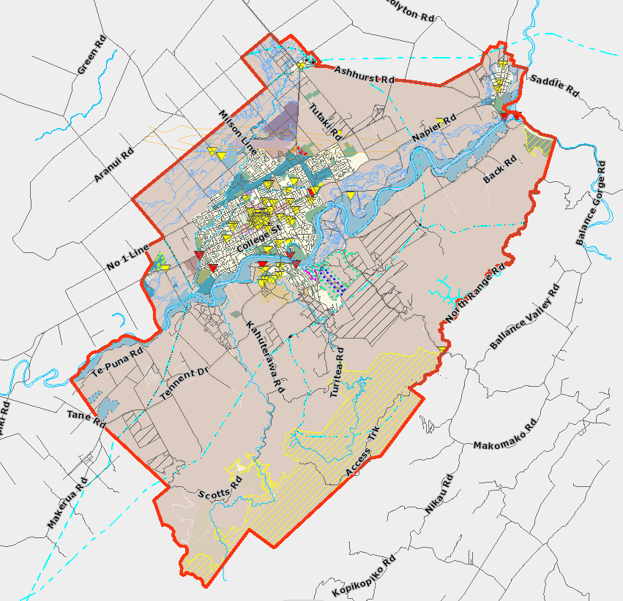
Local Focus: activities must take place within Palmerston North City boundaries, or the applicant must be able to clearly demonstrate benefit to Palmerston North City residents.

You can find a link to an interactive map showing the city boundaries here.

Environmental Benefits: the initiative must demonstrate the specific environmental benefits that will be achieved by implementing the initiative.

Collaboration: if this is a collaborative initiative, you should provide evidence that you have investigated potential partnerships with other groups. We would also like to see you exploring other funding sources for the initiative.

Project Plan: applicants will be required to submit a Project Plan for the initiative. The Plan should cover the objectives of the initiative, a description of how the objectives will be achieved, a timeline and a budget for the initiative. Provision of quotes or estimates for specific items is not compulsory but will be encouraged. A Large Grant application need not be for a new activity but could cover maintenance or expansion of an existing project.

Reporting: how the applicant will measure the initiative’s success – they will need the capability to record and report on the project’s success to ENM.

Past Environmental Initiatives: evidence of success in implementing past environmental projects, if applicable.

Applicant Status: applications will only be accepted from organisations, not individuals; successful applications will not be paid into an individual’s bank account. Where the applicant does not have a bank account, an umbrella organisation may be used; the applicant will need to supply full details of the umbrella organisation.
Applications from legal entities are preferred. Applications from businesses will be accepted but environmental initiatives must not support profit-making activities.

Requested Grant: must be more than $1,000 and must not exceed $12,000, exclusive of GST.

Paid staff costs: may be applied for in the budget.

Delivery: evidence that the applicant has the capability and capacity to deliver the initiative within the expected timeline.

Fund Details

Funding Availability

The fund opens on Tuesday, 30 January 2024.

The maximum funds an applicant can receive in any funding year is 12,000 for Large Grants.

Applications for Large Grants will close at 4pm, on Thursday, 14 March 2024.

Only one round will be held for Large Grant applications this funding year which ends 30 June 2024.

Other points to note when submitting Large Grant applications are as follows:

- Payment will be made in the form of a grant.
- The grant may be paid in more than one instalment.
- The full amount requested may not necessarily be granted.
- Retrospective expenses will not be covered by Large Grants. The date that retrospective spending applies to is the date applicants receive notice of funding. Expenses incurred before that date will not be funded.

Fund Allocation Process

Assessment and allocation of funds will be carried out by ENM’s Funding Distribution Subcommittee.

The Funding Distribution Subcommittee (FDS) includes representatives from ENM’s Management Committee, ENM Member Groups and other community organisations.

FDS will meet mid-April (after the Large Grant Funding Round closes and following Easter) to make recommendations to ENM’s Management Committee (MC) on funding allocations for 2023-24 (ending 30 June 2024).

FDS members must declare their interest in any application they are associated with or have an interest in. They must remove themselves from discussion and decision making on that application. Conflicts of interest will be recorded in the minutes of the meeting.

ENM’s MC will consider FDS recommendations and decide on funding allocations for 2023-24 (ending 30 June 2024).

Applicants are also required to advise the status of the group seeking funding and to declare any conflicts of interest.

Final decisions on funding are at the discretion of ENM’s MC.

Reporting Requirements

Initiatives can commence upon announcement of successful funding and will be expected to be completed within 12 months.

A report on the initiative must be submitted by the due date stated in the notice of funding approval. This report must include:

- photographic or video evidence of the initiative’s completion.
- a review of the outcomes of the initiative.
- an evaluation of how successful the initiative has been in achieving its stated objectives.
- how the initiative has contributed to the environmental priorities (see ‘EIF Priorities and Criteria 2023/24’ above) in this year’s funding round; and
- how the community and the environment has benefited from the project.

In the case that an initiative is NOT completed, or only partially completed within the agreed timeframe for any reason, then:
- if a formal request is made, the FDS has discretion to grant an extension of time for the completion of the project; and
- the FDS may require the full or partial return of project funds to ENM so that any returned funds can be reallocated in the next funding round, or as soon as practicable.

Successful applicants will be required to acknowledge the funding on the applicant’s social media and/or website and in their Annual Report.

Terms of Agreement/Declaration

Applicants must ensure that these sections of the form are completed fully.

